Scots Language CLPL Reading List

Books and Web links

Books:

Corbett, J; Language and Scottish Literature: Teaching Scottish Language and Literature Corbett, J; The Edinburgh companion to Scots
Kay, Billy; Scots: The Mither Tongue

MacDougall, Carl; Scots: The Language of the People Robinson, Christine; Modren Scots Grammar Wilson, Colin L; Luath Scots Language Learner

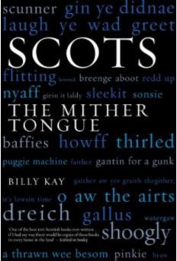
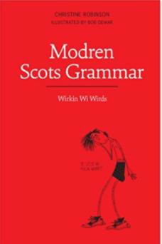
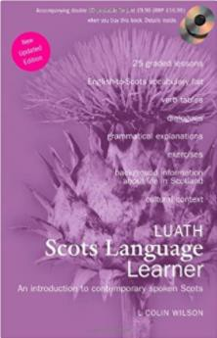

Links:

An Investigation of Attitudes to Scots and Glasgow Dialect Among Secondary School Pupils; Menzies, Janet

Ane Instructioun for Bairnis to be Learnit in Scottis: A Study of Scots Language in the
Scottish Secondary Classroom; Lowing, Karen
On the Pros and Cons of Standardizing Scots; Costa, James

Resources from Education Scotland:
Curriculum for Excellence: Scots Language
Scots Language in Curriculum for Excellence

Language, migration and identity at school: a sociolinguistic study with Polish adolescents in Glasgow; Ryan, Sadie Durkacz
Scotland’s linguistic past and present: paradoxes and consequences; Nihtinen, Atina L. K.

Scots in the Scottish Curriculum (blog post); Clark, Adam

Scots Language Award (SQA)
Scots Language policy (Scottish Government)
SCOTS: The Scots language in education in Scotland; Niven, Liz

The Aitken Papers; Aitken, A.J
The Scots Language in Curriculum for Excellence; Hodgart, John
TES articles:
The importance of using Scots language in the classroom; Eunson, Bruce
Using Scots language in class is immensely valuable; Eunson, Bruce
Scots language has a place in schools - but where exactly?; Gillespie, Alan

Use it or Lose It: New reading for Children in Scots; Fitt, Matthew

